* [Produce a timestamp for 1 a.m. on the 31st of August 2012](https://pgexercises.com/questions/date/timestamp.html)

delete from cd.members where memid not in (select memid from cd.bookings);

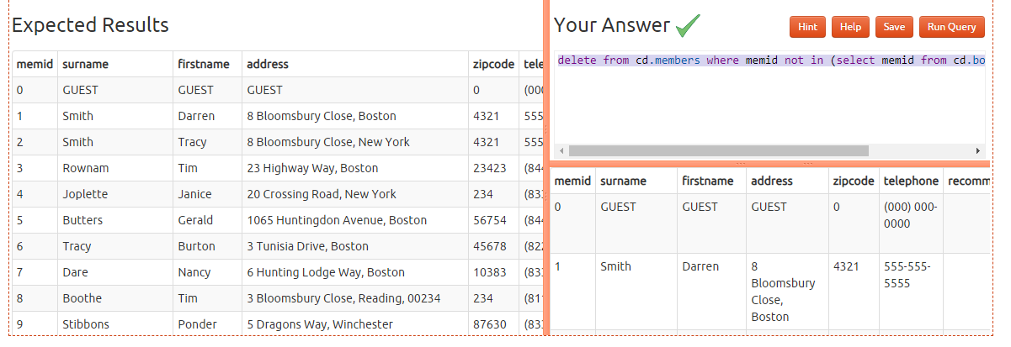

* [Subtract timestamps from each other](https://pgexercises.com/questions/date/interval.html)

select timestamp '2012-08-31 01:00:00' - timestamp '2012-07-30 01:00:00' as interval;

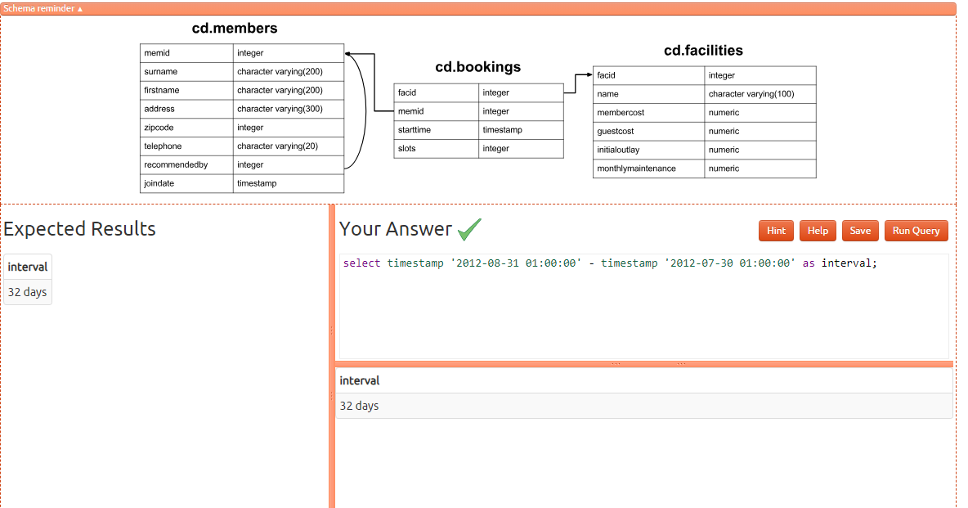

* [Generate a list of all the dates in October 2012](https://pgexercises.com/questions/date/series.html)

select generate_series(timestamp '2012-10-01', timestamp '2012-10-31', interval '1 day') as ts;

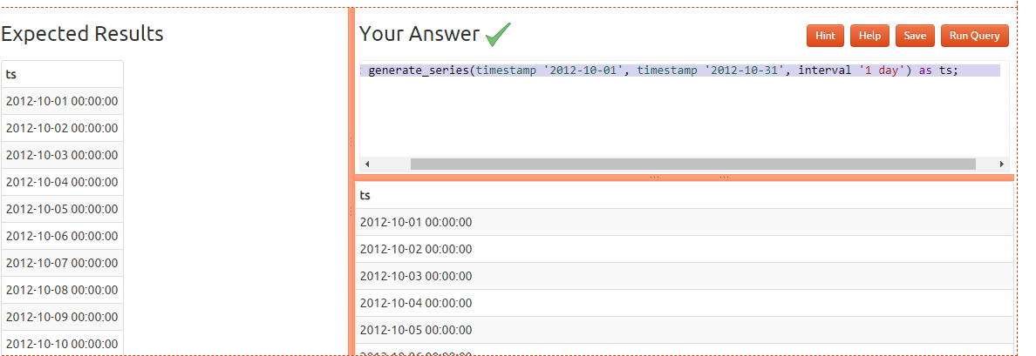

* [Get the day of the month from a timestamp](https://pgexercises.com/questions/date/extract.html)

select extract(day from timestamp '2012-08-31'); 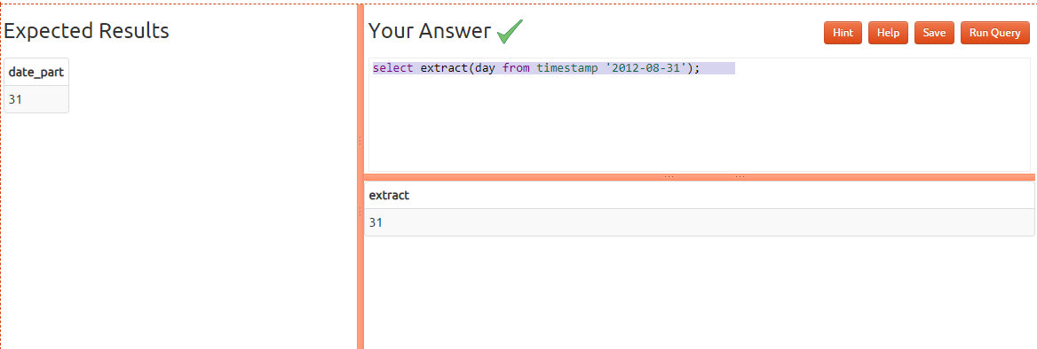

* [Work out the number of seconds between timestamps](https://pgexercises.com/questions/date/interval2.html)

select floor(extract(day from ts.int)*60*60*24 +

extract(hour from ts.int)*60*60 +

extract(minute from ts.int)*60 +

extract(second from ts.int))

from

(select timestamp '2012-09-02 00:00:00' - timestamp '2012-08-31 01:00:00' as int) ts; 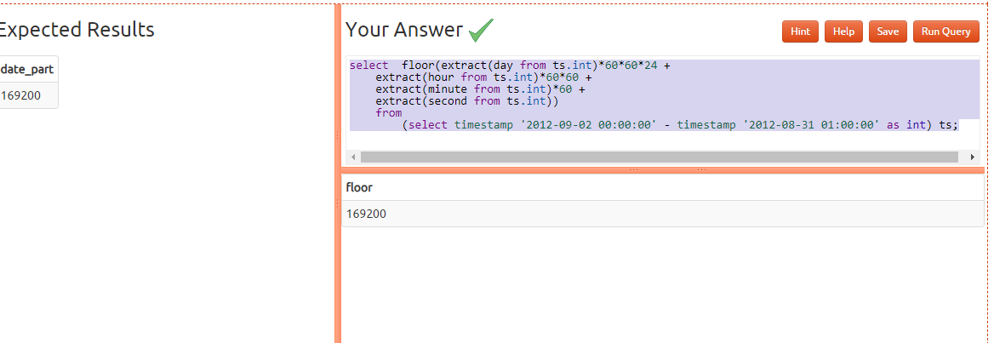

* [Work out the number of days in each month of 2012](https://pgexercises.com/questions/date/daysinmonth.html)

select extract(month from cal.month) as month,

(cal.month + interval '1 month') - cal.month as length

from

(

select generate_series(timestamp '2012-01-01', timestamp '2012-12-01', interval '1 month') as month

) cal

order by month;

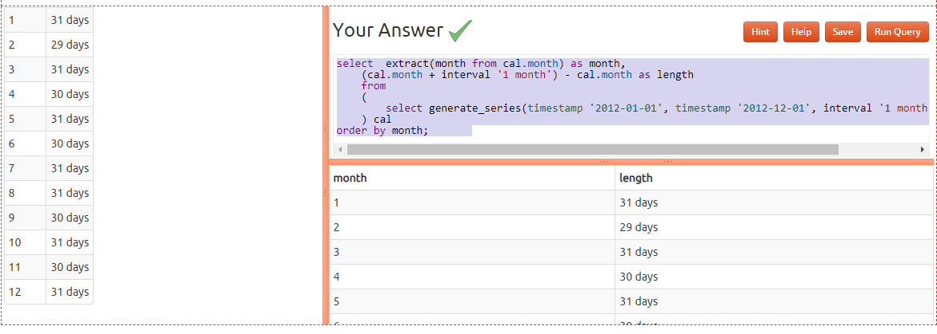

* [Work out the number of days remaining in the month](https://pgexercises.com/questions/date/daysremaining.html)

select (date_trunc('month',ts.testts) + interval '1 month')

- date_trunc('day', ts.testts) as remaining

from (select timestamp '2012-02-11 01:00:00' as testts) ts;

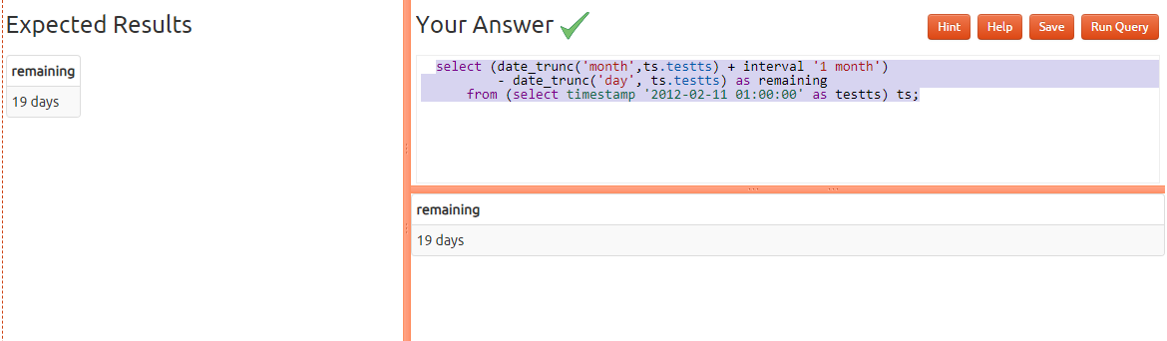

* [Work out the end time of bookings](https://pgexercises.com/questions/date/endtimes.html)

select starttime, starttime + slots*(interval '30 minutes') endtime

from cd.bookings

order by endtime desc, starttime desc

limit 10

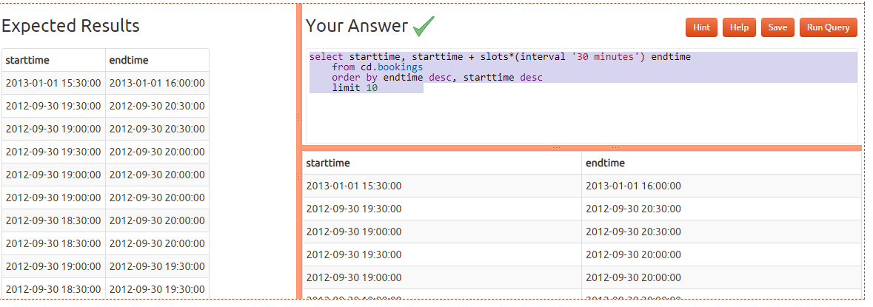

* [Return a count of bookings for each month](https://pgexercises.com/questions/date/bookingspermonth.html)

select date_trunc('month', starttime) as month, count(*)

from cd.bookings

group by month

order by month

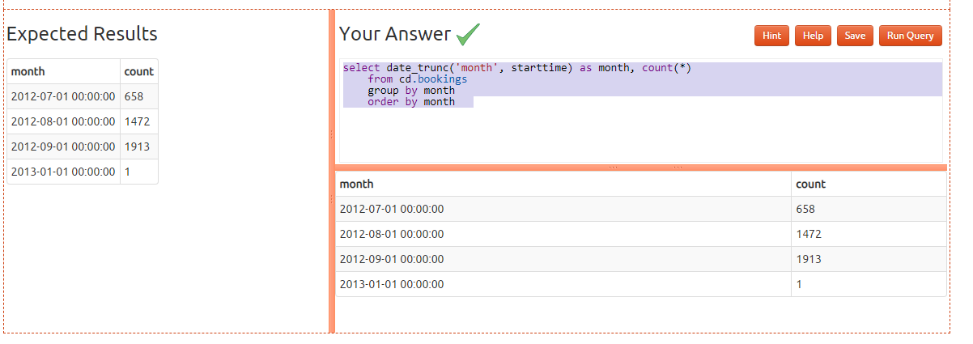

* [Work out the utilisation percentage for each facility by month](https://pgexercises.com/questions/date/utilisationpermonth.html)

select name, month,

round((100*slots)/

cast(

25*(cast((month + interval '1 month') as date)

- cast (month as date)) as numeric),1) as utilisation

from (

select facs.name as name, date_trunc('month', starttime) as month, sum(slots) as slots

from cd.bookings bks

inner join cd.facilities facs

on bks.facid = facs.facid

group by facs.facid, month

) as inn

order by name, month

